Hunting for cancer stem cells
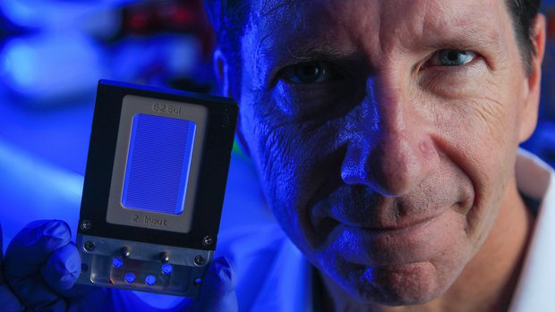
Jeff Allen, who is developing a cancer diagnostic chip similar to this one, poses for a picture in Nick Cosford's research lab at the Sanford Burnham Medical Research Institute. The chip Allen is developing would isolate cancer stem cells for diagnosis.

After Jeff Allen’s wife died of cancer in 2002, the analytical biochemist put his training to work in learning more about the disease.
Doing so was initially a “hobby,” he said. “As time progressed, it became more than a hobby. It became a downright obsession. I got angry at cancer, and as the years went, by I became frustrated with the slow pace” of developing new weapons against it.
Allen, whose background includes development of molecular diagnostic devices, began studying how cancer treatment could be improved.
Now he and his sons, Alexander and Austin, said they’ve designed a device that can detect the most dangerous cancer cells, often calledcancer stem cells. The device is still in the concept phase, but scientists who have looked at the technology think it’s feasible.
The device is envisioned as a microchip that examines a patient’s blood sample to identify and isolate cancer stem cells. Once captured, these cells would be genetically sequenced to find the mutations driving the cancer. Then doctors could prescribe the most customized treatment based on this more rigorous analysis.
To carry out his plan, Allen is seeking $50,000 through the crowdfunding site gofundme.com. He also has formed a company,TumorGen MDx.
In the world of oncology, there’s increasing — but not total — recognition of cancer stem cells and their destructive role. Allen said his own reading of the literature is that these cells do indeed exist. They possess distinct characteristics that enable them to seed an entire new tumor from just a few cells, or perhaps only one.
That theory carries tremendous significance for accurate diagnosis. A drug that inhibits most cancer cells but misses the cancer stem cells won’t do much good.
“We need to expand research on cancer stem cells,” Allen said.
While cancer centers are doing such testing, he added, the existing technology is slow and expensive.
“Imagine taking a 10 milliliter blood sample and putting it into a tiny capillary, one cell at a time,” Allen said. “You can see that’s a rate-limiting step, and I think that’s why research is very limited. Only the largest cancer centers can have a team of people and the money to run this equipment.”
Allen said he’s designing his chip to work with more than blood, because cancer stem cells circulating in the bloodstream can be rare. The chip would be able to screen tissue samples such lymph node biopsies.
New combination
Allen’s concept combines micro-fluidics with antibody technology and a dissolvable gel. He intends to etch his chip with tiny channels for the blood to flow into. The channels would be coated with a gel containing antibodies that preferentially attach to antigens, or proteins commonly found on cancer stem cells.
“Only the cells that have the surface antigen are going to stick to the walls,” Allen said. “Now we can dissolve that gel and move that captured cell to a different area coated with a different antibody.”
The process will be performed three times, to confirm that the cells collected really are cancer stem cells.
“Too many researchers are only looking for a single surface protein and a single receptor, and right now the science isn’t mature enough,” Allen said. “So you need multiple surface antigens to say, ‘Yes, I have a cancer stem cell.’”
Also importantly, the device’s tiny channels are wide enough to pass clusters of these circulating cancer stem cells. Research has indicated that clusters of these cells are associated with increased risk of metastases in breast cancer.
“So a key element of that chip design is to maintain that cluster, and we can do that with this gel technology,” Allen said.
Nicholas Cosford and Peter Teriete at the Sanford-Burnham Medical Research Institute in La Jolla said Allen’s idea is worth trying.
“The results he’s shown look very promising,” said Cosford, a professor in the institute’s cancer center. “It’s a novel approach that has quite a lot of potential. I think under the right circumstances, it could really move things along in the field.”
Teriete said Allen has discovered a way to combine established technologies.
“Jeff Allen’s approach is not to reinvent the wheel,” Teriete said. “He’s using really well-established technologies in a novel way and adding his personal twist to it. I feel the likelihood of success is actually quite high.”
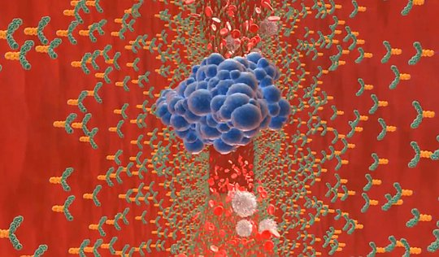
A cluster of cancer stem cells, blue, is caught by antibodies in this animation of how the diagnostic chip would work. — Jeff Allen
Path to product
Allen’s work is not near the commercialization stage.
“He has been scouring a lot of the existing literature and talking to experts in the field to solidify the underpinnings of his approach,” Teriete said. “He has designed a chip that should enable him to conduct feasibility studies to show proof of concept — that it would work.”
The next step is to find a microchip foundry to make the chip, Teriete said.
Cell-based experiments would come next, followed by tests conducted on patients’ blood and tissue samples. The testing stage could take three to six months.
Engineering and optimization would be the subsequent processes — to ensure the device functions the way it’s intended. No matter how well something is designed on a computer, real-world experience is always needed, Teriete said.
Allen said once he gets a good prototype, he will take it to a comprehensive cancer center to see if a partnership is possible. These centers are willing to work with products just coming out of research and see whether those devices can improve treatment for patients.
At the moment, money remains a bottleneck. Of the $50,000 hoped for, less than $6,700 has been raised.
“Right now I’m working out of my home,” Allen said. He plans to collaborate with a professor at San Diego State University who has available lab space and students.
“It would be a perfect fit,” Allen said.

